**Objective Questions**:

1. What is the total no. of tables present in the data?

**Ans.**

There are 2 tables in the final excel file. One is inside the raw data sheet (original table) and second one is inside Table 1 sheet (a dynamic table created using power query editor, so that it doesn’t affect the original data, with some new added columns according to the requirement).

1. What is the total no. of attributes present in the data?

**Ans.** Raw Data Tabel=21 & Table 1 = 26

1. How many categorical columns are there in the data?

**Ans.** 15

1. The data consists of some inconsistent and missing values so ensure that the data used for further analysis is cleaned.

**Ans.**

**Approach: -**The missing values can be found out by filtering out the blank values using proper filter option. Or by looking the “Column Quality” option inside View Tab of Power Query Editor.

Missing values were there for cuisines of USA, which is filled up by maximum occurrence of cuisines in USA by using a pivot table and then drawing out the max using LOOKUP function.

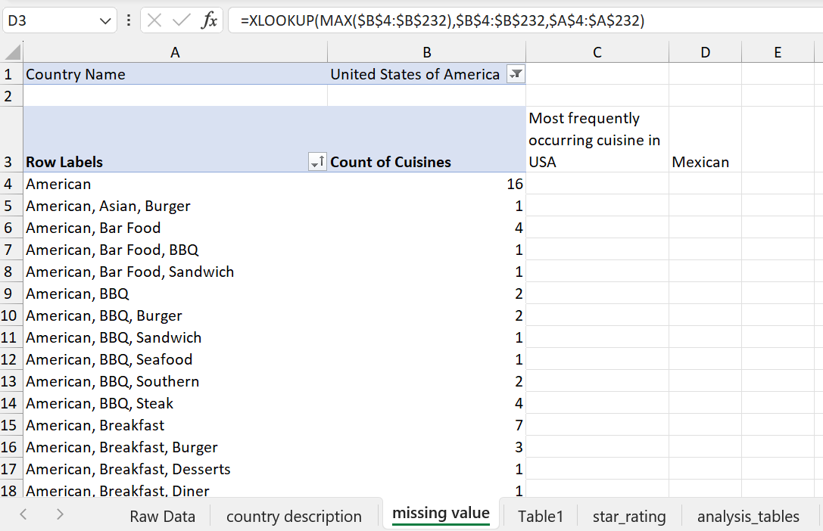

1. Using the LookUp functions, fill up the countries in the original data using the country code.

**Ans.**

**Approach: -** It can be done by using XLOOKUP function (XLOOKUP can search both vertically and horizontally)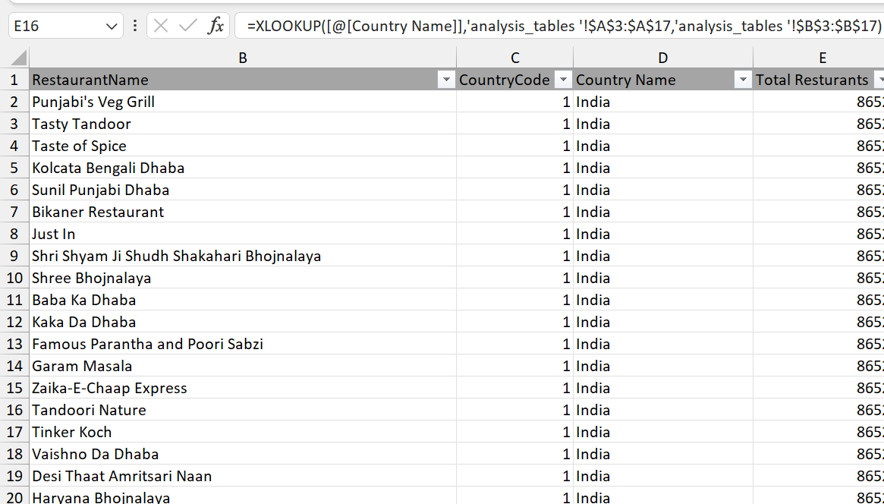

1. Create a table to represent the number of restaurants opened in each country.

**Ans.**

**Approach: -** For this I have used the pivot table. In which “Country Name” is putted in the rows and “Restaurant Id” is putted in value field and changed the field setting to count of “Restaurant Id” of pivot table, so that we can get count of restaurants for each country.

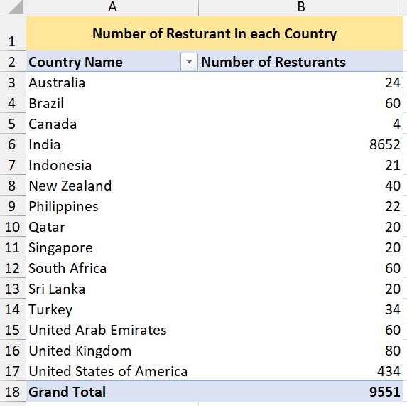

1. Also, the management wants to look at the number of restaurants opened each year, so provide them with something here.

**Ans.**

**Approach: -** For this I have used the pivot table. In which “Year of Opening” column is putted in the rows and “Restaurant Id” is putted in value field and changed the field setting to count of “Restaurant Id” of pivot table, so that we can get count of restaurants for each year.

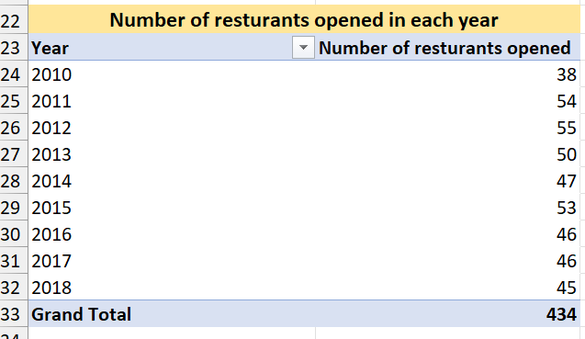

1. What is the total number of restaurants in India in the price range of 4?

**Ans.**

**Approach: -** Using conditional aggregation function COUNTIFS we can achieve this, because we have to look for 2 criteria here, first one is where country is “India” and second one is having “price range” is equals to 4. So, I’ve putted the country name column range in criteria_range_1 (first parameter of COUNTIFS function), “India” in criteria1 (second parameter of COUNTIFS function), Price Range column range in criteria_range_2 (third parameter of COUNTIFS function) and “4” in criteria2 (fourth parameter of COUNTIFS function), to get the desired result as shown below.

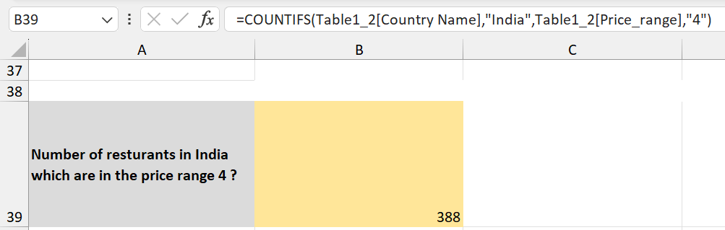

1. What is the average number of voters for the restaurants in each country according to the data?

**Ans.**

**Approach: -** For this I have used the pivot table. In which “Country Name” column is putted in the rows and “Voters” is putted in value field and changed the field setting to average of “Restaurant Id” of pivot table, so that we can get average number of voters for the restaurants in each country.

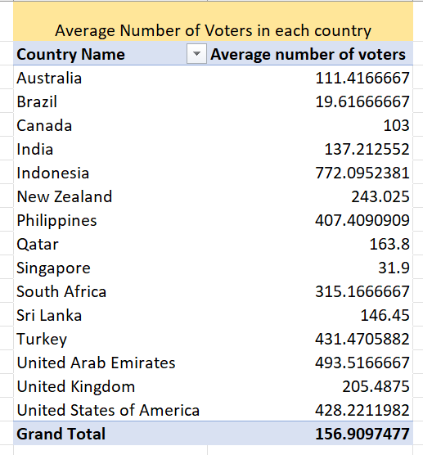

1. Calculate the average rating for all the restaurants that have price_range < 4 and provide online delivery. Use only the “IF” function, Logical Operators, and Aggregation functions to solve this problem. **[Note: Don’t use Conditional aggregation in this question.]**

**Ans.**

**Approach: -** Instead of using conditional aggregation function “AVERAGEIF”, I’ve done this using Average and If condition in a nested way. Firstly, IF condition will look for cells which have Price_range less than 4 and simultaneously having “Yes” in the Has_Online_delivery. Then, AVERAGE function will calculate the average of Ratings column for those values which we get from the IF condition.

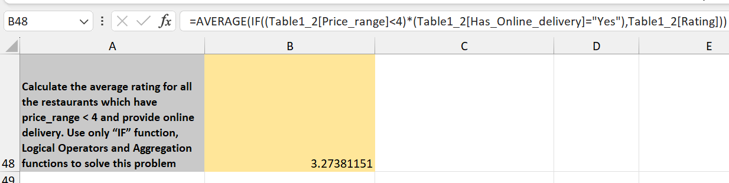

1. Using Conditional formatting highlight the rows of restaurants that are located in the countries or cities that you’ve suggested to the management for opening new restaurants.

**Ans.**

**Approach: -**

We can see the name and approach used to filter out names of the suggested countries and cities in the subjective question 1 and 2 respectively. After this, I have used the cities name (which is in the column F) to highlight the name of restaurants inside that suggested city. The formula of which (conditional formatting) is given below and each names of restaurants can be seen in excel sheet named “Restaurants in suggested Cities”.

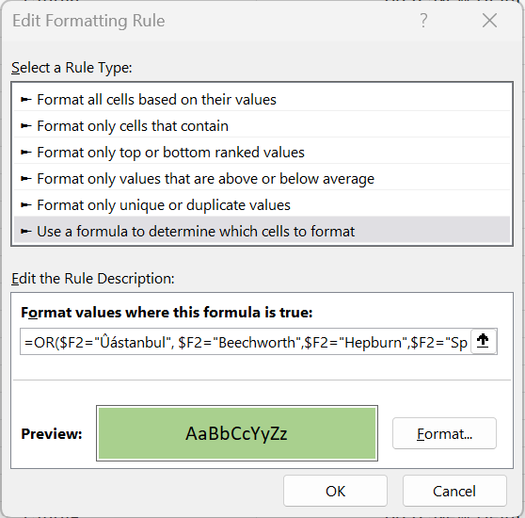

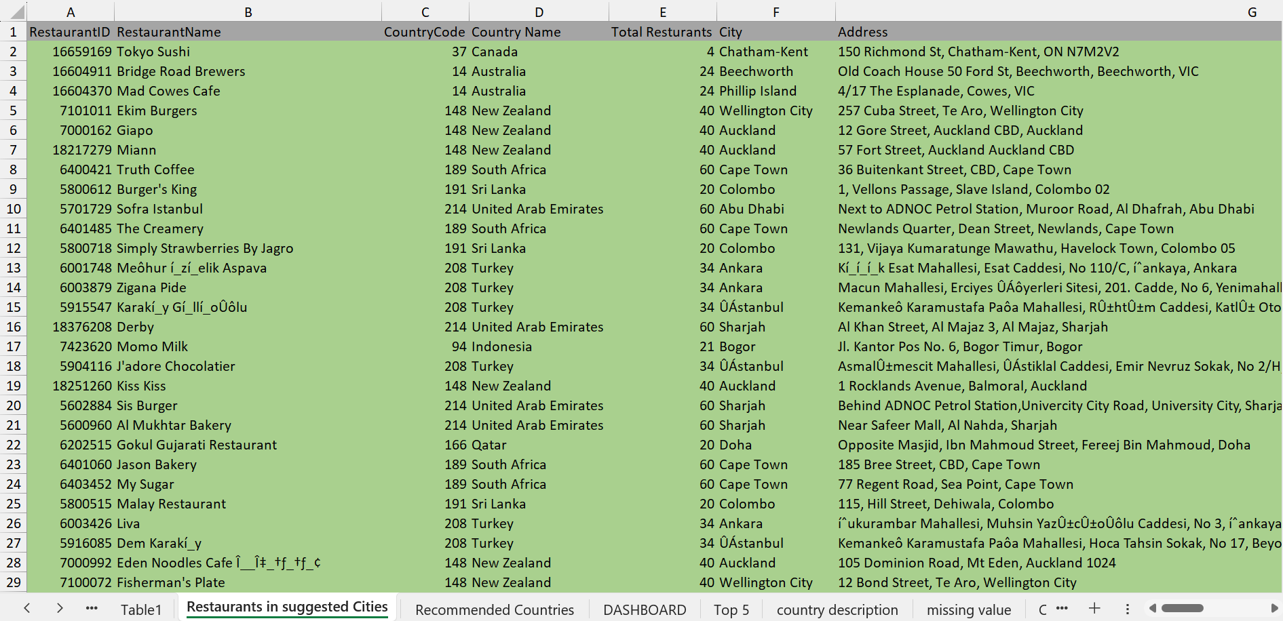

**\*You can see all highlighted rows in the excel file “Restaurants in suggested Cities” sheet.**

1. Create a new customized price column that consists of the abbreviation/symbol of the currency along with the Average_cost_for_two values. [Use string operations to do this task]

**Ans.**

**Approach: -**

**Step 1:** This is done first by fetching currency symbols from the “Currency” column using the MID, SEARCH function together, and putted it in “Currency (Imputed)” column.

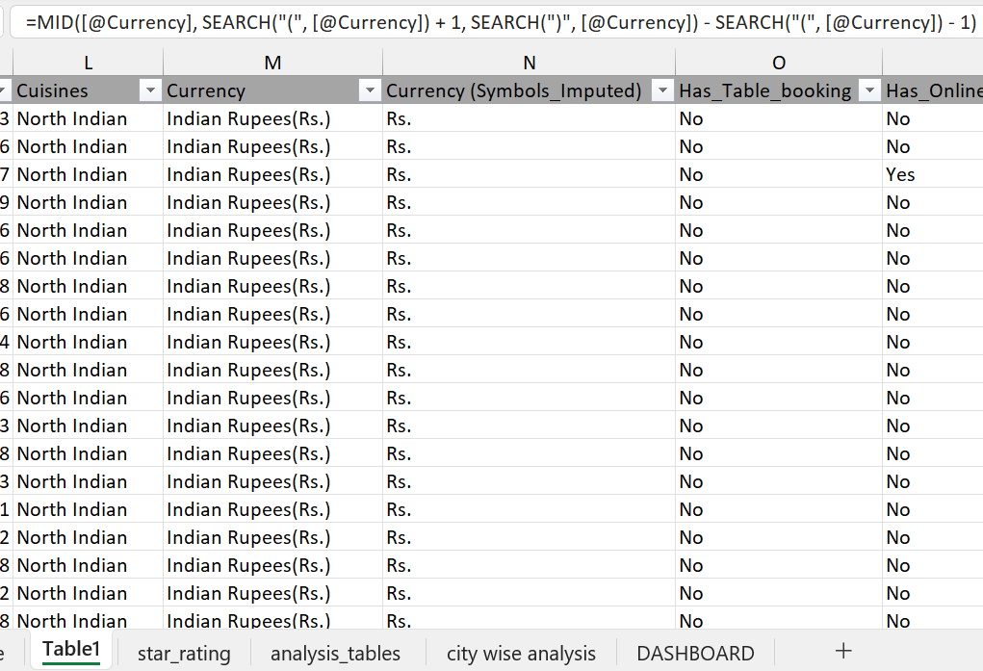

**Step 2:** Then concatenating the Currency (Imputed)” column with “Average_cost_for_two” and naming the new customized column as “Price (Imputed)”.

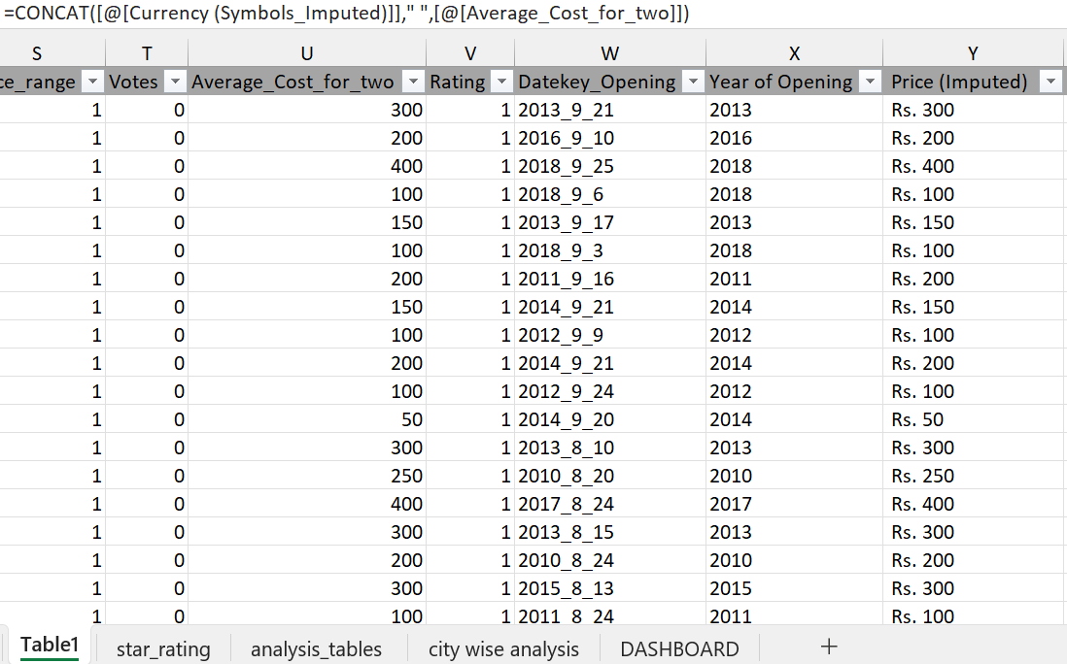

1. How can you create an array formula in Excel or Google Sheets to count the number of restaurants listed that do not offer online delivery, are in the lowest price range, and have an average cost for two people less than or equal to 250 Indian Rupees?

**Ans.**

**Approach: -** As there is no restriction mentioned in this question so I’ve used the conditional aggregation formula COUNTIFS to solve it, because we have to look for multiple criteria here, first one is where has_online_delivery is “No”, second one is having “price range” is equals to 1 (i.e. lowest price_range), third one is having an average_cost_for_two people less than or equal to 250 Indian Rupees i.e Price_Imputed less than equals to 250 rupees. So, I’ve putted the has_online_delivery column range in criteria_range_1 (first parameter of COUNTIFS function), “No” in criteria1 (second parameter of COUNTIFS function), Price Range column range in criteria_range_2 (third parameter of COUNTIFS function) and “1” in criteria2 (fourth parameter of COUNTIFS function), average_cost_for_two column range in criteria_range_3, Price_Imputed less than equals to Rs. 250 in criteria3 to get the desired result as shown below.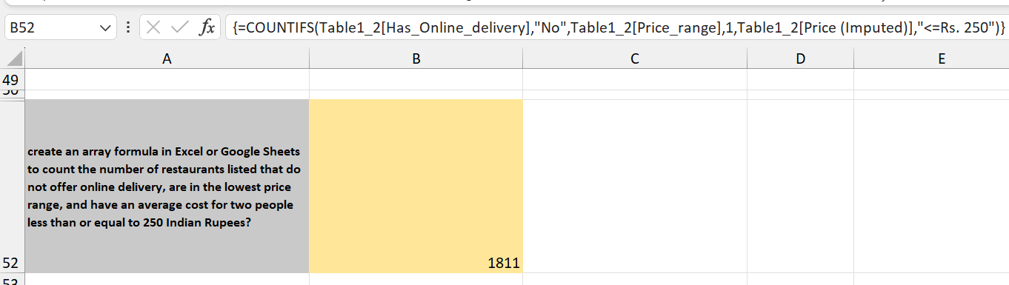

**Subjective Question:**

1. Suggest a few countries where the team can open newer restaurants with lesser competition. Which visualization/technique will you use here to justify the suggestions?

**Ans.**

**Suggested Countries: -**

|  |
| --- |
| Australia |
| Canada |
| Indonesia |
| New Zealand |
| Philippines |
| Qatar |
| South Africa |
| Sri Lanka |
| Turkey |
| United Arab Emirates |

**Approach: -** We can analyse it by keeping following criteria in mind

1. Country with less restaurants than 200.

2. Restaurants in that country which has rating>=3.

3. Restaurants in that country which has avg_cost_for_two <= Rs 1600 and not 0 (after converting each avg_cost_for_two to any one currency). The average cost for two person to eat food in Indian Rupee ranges from Rs 800-Rs2000, therefore, Rs 1600 (a middle value is taken) for the analyses.

4. Votes (number of persons visited) >150 in that restaurant

**Visualization: -** We can use conditional formatting to fetch lesser competition countries and a dashboard to visualize the analyses.

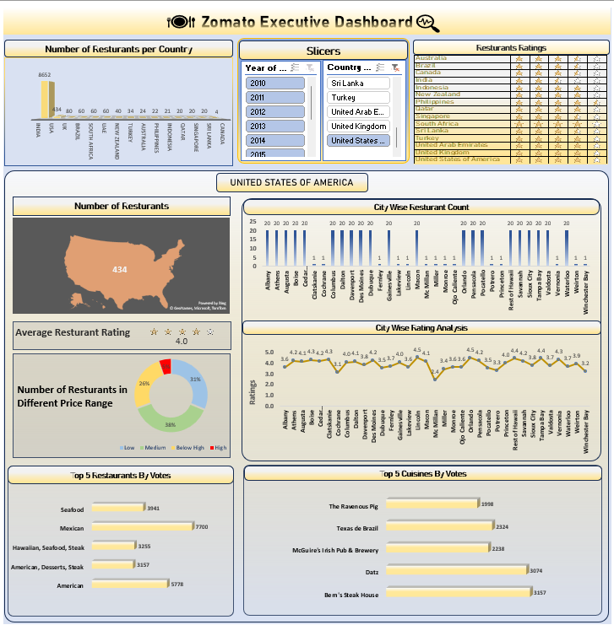

1. Come up with the names of cities in the suggested countries suitable for opening restaurants.

**Ans**.

**Approach: -** For this I have used the pivot table. In which “Country Name” column is putted in the rows and “Restaurant Name” is also putted in rows field so that we can get name of restaurant in the suggested countries.

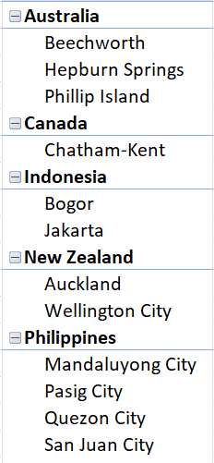 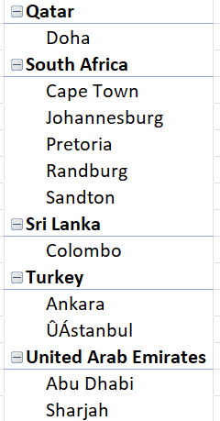

1. According to the countries you suggested, what is the current quality regarding ratings for restaurants that are open there?

**Ans.**

**Approach: -** Using the pivot table, in which “Country Name” column is putted in the rows and “Ratings” is putted in value field and changed the field setting to average of “Ratings” of pivot table, so that we can get average ratings for the restaurants in each country which is shown below. Now, using conditional formatting feature of Excel to represent the average rating using the star symbols.

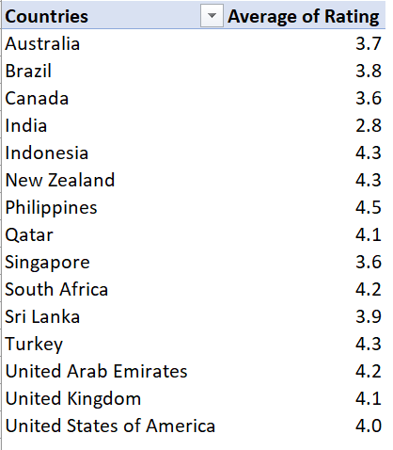

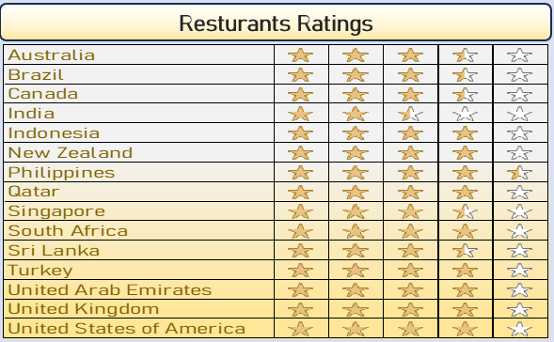

1. Also, what is the current expenditure on food in the suggested countries, so we can keep our financial expenditure in control?

**Ans.**

**Approach: -** By calculating the average expenditure on food using the “Average_cost_for_two” column we can get the current expenditure on food in the suggested countries.

For this I have used the pivot table. In which “Country Name” column is putted in the rows and “avg_cost_for_two (Rs.)” column is putted in value field and changed the field setting to average of “avg_cost_for_two (Rs.)” of pivot table.

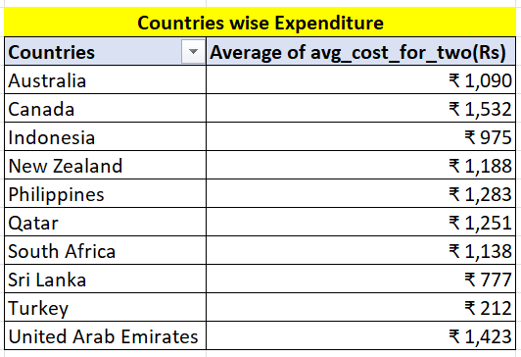

1. Come up with the names of restaurants from the recommended states that are our biggest competitors and also those that are rated in the lower brackets, i.e. 1-2 or 2-3.

**Ans.**

**Biggest Competitors criteria: -**

* + - 1. Restaurant rating>=3
      2. avg_cost_for_two< Rs 1600
      3. Number of Voters > 150

**Restaurants Name: -**

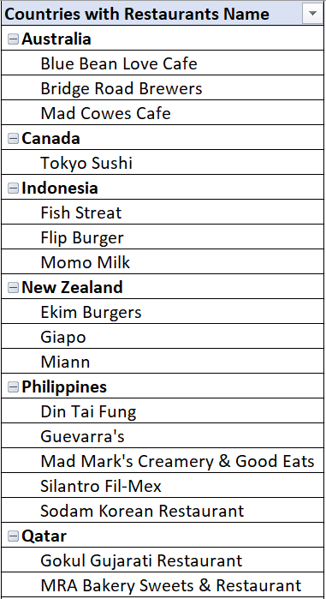 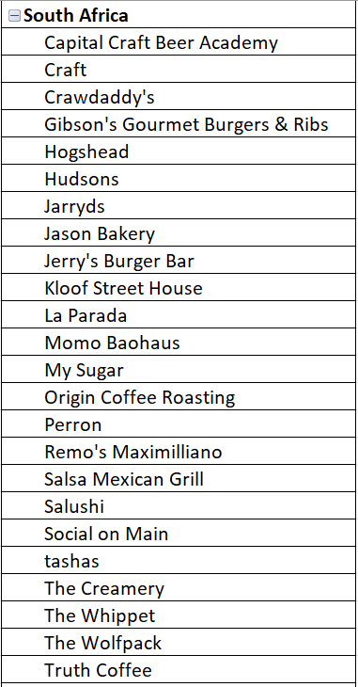

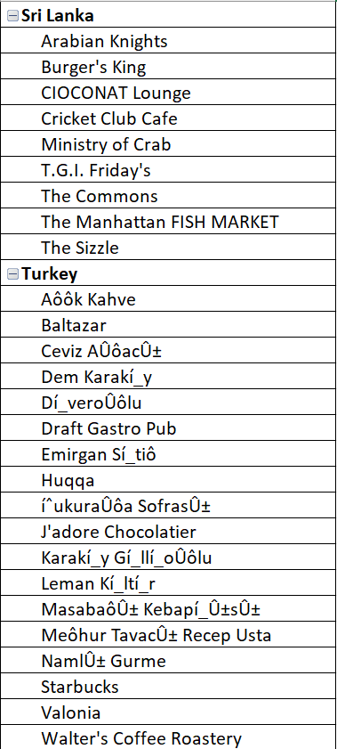 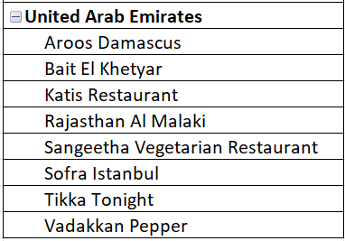

1. Which cuisines should we focus on in the newer restaurants to get better feedback? Does the choice of cuisines affect the restaurant ratings?

**Ans.**

**Approach: -** To get better feedback in the new restaurants we should focus on that cuisines which are already performing well among all the cuisines i.e having maximum rating. I’ve used the pivot table to achieve this.

Yes, the choice of cuisines does affect the restaurant ratings.

|  |  |  |
| --- | --- | --- |
| **Countries** | **Cuisine that should be focused upon** | **Max Rating** |
| **Australia** | **Pizza, Bar Food** | **4.6** |
| **Canada** | **Japanese, Sushi** | **3.7** |
| **Indonesia** | **Burger** | **4.4** |
| **New Zealand** | **Desserts** | **4.9** |
| **Philippines** | **Filipino, Mexican** | **4.9** |
| **Qatar** | **Indian** | **4.3** |
| **South Africa** | **Cafe, Burger** | **4.8** |
| **Sri Lanka** | **Seafood** | **4.9** |
| **Turkey** | **Bar Food** | **4.9** |
| **United Arab Emirates** | **Indian, North Indian** | **4.8** |

1. According to our current data, should we go for online delivery and table booking? Does that affect the customer’s ratings?

**Ans.**

**Approach: -** In order to give suggestions for new restaurants we have to analyse the trend of online delivery and table booking in each country and how the rating changes for that.

For this, I’ve used the pivot table and sparkline feature, so that we can get ratings trends for each country with respect to Online Delivery & Table Booking.

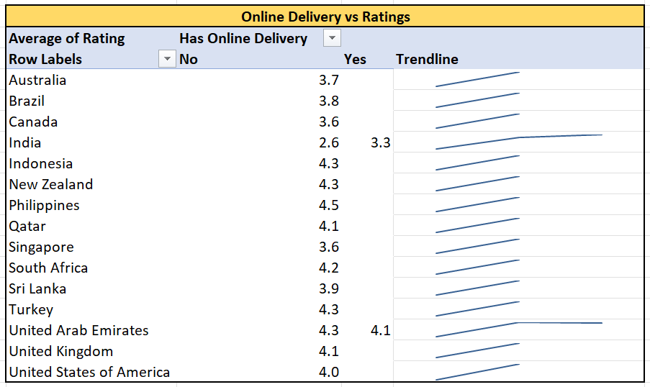

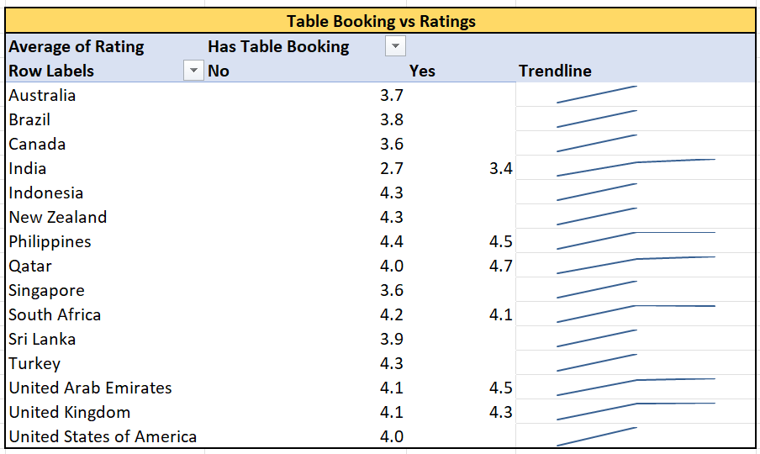

**Insights: -** Those restaurants which are having online delivery and table booking both are showing an increase in ratings. Therefore, we can say that online delivery and table booking does affects the customer’s ratings.

**Recommendations: -** Include features of online delivery and table booking for the ease of customer.

1. Should the team keep the rate of cuisines higher? Will that affect the feedback? According to our data are the rates of cuisines and ratings, correlated?

**Ans.**

**Approach: -** Using “Correlation Analysis” and pivot table I have visualized the distribution of cuisine ratings and avg_cost_for_two for each country using a scatter plot along with a linear forecast trendline (to show the general trend and direction of data points, making it easier to visualize any linear relationship in the data).

By calculating the correlation coefficient (“r”) between cuisines ratings and avg_cost_for_two we can measure the strength and direction of the linear relationship between two variables.

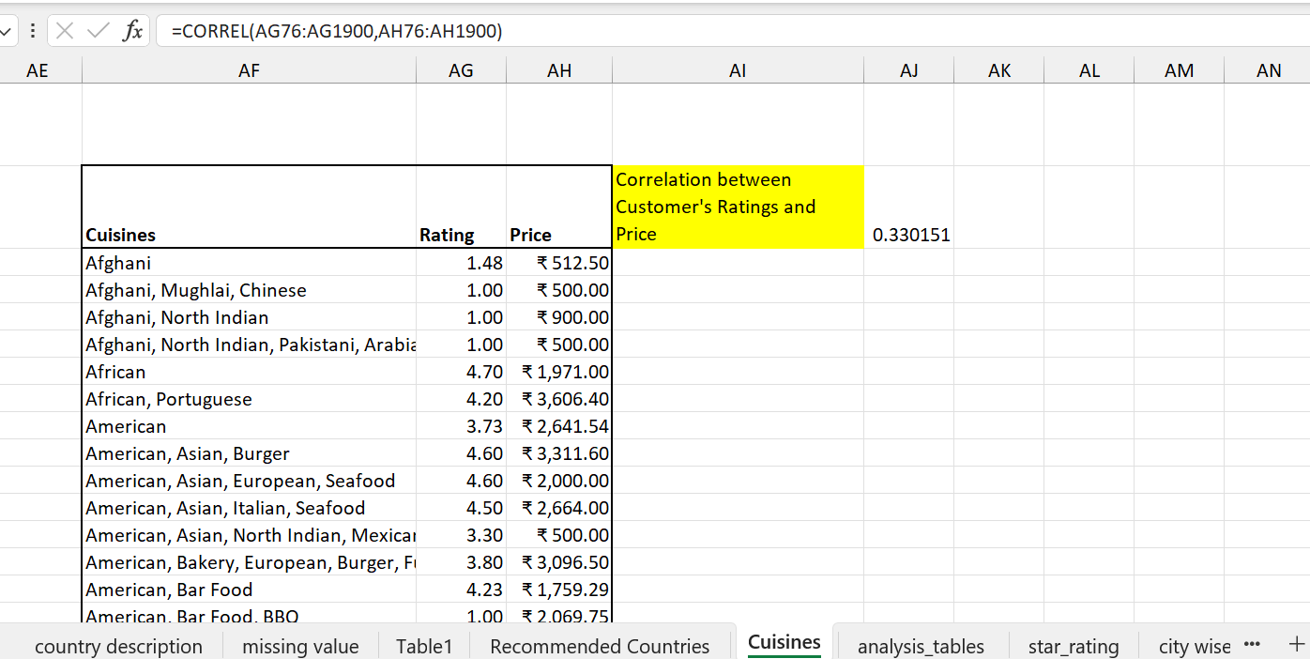

[where =CORREL(Rating, avg_cost_for_two)]

**Insights: -** As the linear forecast trendline is moving slightly upward direction and the correlation coefficient is moving towards +1, therefore, we can say that the rates of cuisines and ratings are positively correlated i.e as one variable increases, the other tends to also increase.

**Recommendation: -** Seeing the insights doesn’t mean we should increase the price of every cuisine in every country to get better ratings. We should also look the country wise scatter plot for the rating and average price, and increase the rate where the country allows to do so.

1. What is the distribution of the number of restaurants of different price ranges in all the countries?

**Ans.** Using pivot table we can find it, in which “Country Name” column is putted in the rows, “Price_range” is putted in column and also “Price_range” in values field and changed the field setting to count of “price_range” of pivot table, so that we can get count of different price ranges across different countries.

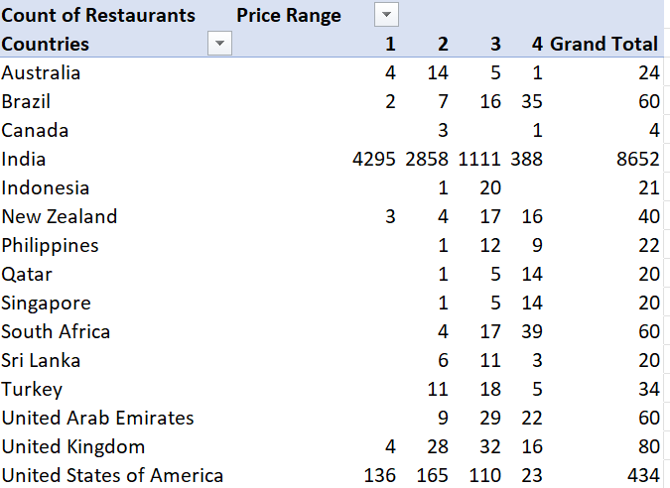

**Visualization: -** Doughnut chart because we have to represent different portions (i.e price_range) occupying space in a single entity (i.e country).

1. Explain your approach in brief for suggesting countries/cities in order to open new restaurants, if the objective and subjective questions would have not been given to assist you. **[you have to give bullet pointers in order to answer this question]**

**Ans.**

* 1. Conduct thorough market research to identify countries with growing economies and favourable business environments for restaurant expansion.
  2. Consider qualitative factors such as cultural fit, cuisine preferences when selecting suitable countries and cities for restaurant expansion.
  3. Conduct thorough analysis of restaurant density and competition in various countries.